1. Project Title: AI-Based Intelligent System for Skin Disease Detection and Healthcare Recommendation
2. Project Statement and Outcomes:
- Current skin disease diagnostic methods are often slow and require expert intervention. This project aims to develop an AI-powered skin disease detection system to automatically classify skin diseases from uploaded images, provide early diagnosis, and help users connect with the right healthcare professionals.
- The output of this project will be a comprehensive Skin Disease Detection System that automatically classifies uploaded skin images into specific disease categories, such as Acne, Rosacea, Basal Cell Carcinoma, Melanoma, and others. Based on the detected disease, the system will suggest relevant hospitals for further diagnosis and treatment. Additionally, users will have the opportunity to provide feedback on the system’s accuracy or their experience. Overall, the system aims to serve as an early detection tool, helping users identify potential skin diseases and connect with appropriate healthcare facilities for timely diagnosis.

3. Modules to be Implemented:
- Data Collection and Preprocessing
- Modal Architecture, Training, Evaluation
- UI Integration and Feedback Mechanism
- Testing, Review, and Documentation
4. Week-wise Module Implementation and High-Level Requirements:
Weeks 1-2: Data Collection and Preprocessing
- Collect and prepare the dataset from Kaggle containing labeled images of various skin diseases.
- Clean the dataset by handling missing or noisy data.
- Split the dataset into training, validation, and testing sets.

Weeks 3-4: Modal Architecture, Training, Evaluation
- Implement an architecture for skin disease image classification.
- Integrate Batch Normalization to enhance the training process and improve model convergence.
- Utilize the Adam Optimizer for efficient and adaptive learning during training.
- Train the model on the dataset and evaluate its performance to assess accuracy and efficiency.
Weeks 5-6: UI Integration and Feedback Mechanism
- Exploring the streamlit.
- Integrate the Hospital Recommendation Module based on the detected disease class.
- Build a web-based user interface for image upload and result display.
- Develop a feedback form for user input.
Weeks 7-8: Testing, Review, and Documentation
- Conduct a thorough review of the entire system, including functionality, security, and user interface.
- Address any identified bugs or issues and perform necessary fixes.
- Prepare comprehensive documentation & presentation covering system architecture, user guides, and technical specification

5. Flow chart:
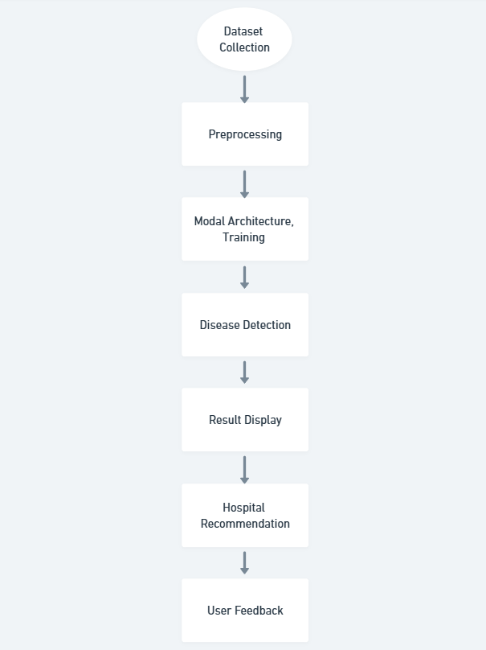
6. Sample output:

